Adam Gincel MA331 Homework 2

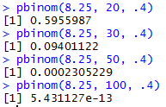

ii. 

iii. 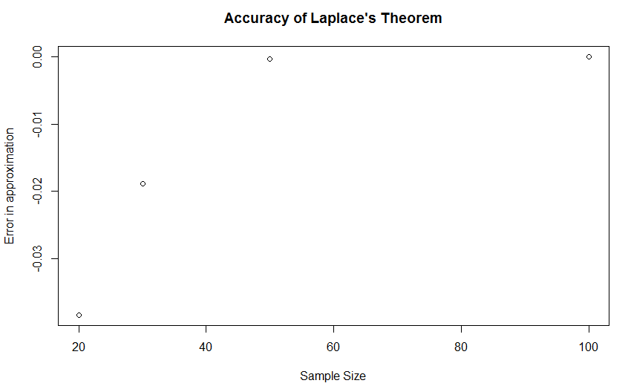

iv. As sample size increases, the difference between Laplace’s Theorem’s approximation and the actual binomial distribution gets smaller and smaller, meaning the theorem’s approximations become more and more accurate.

2 i. 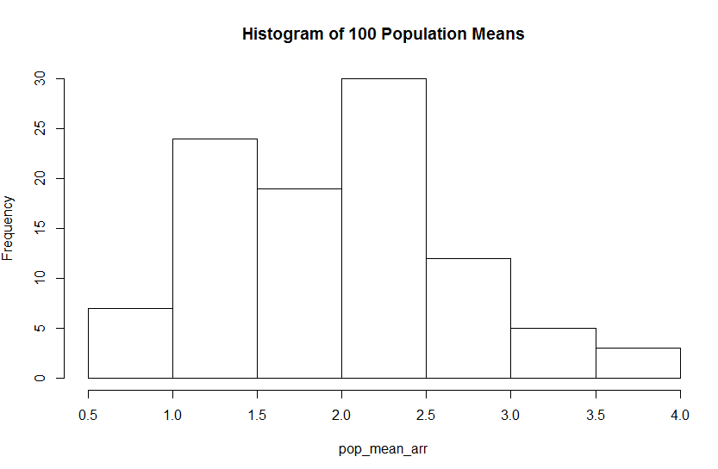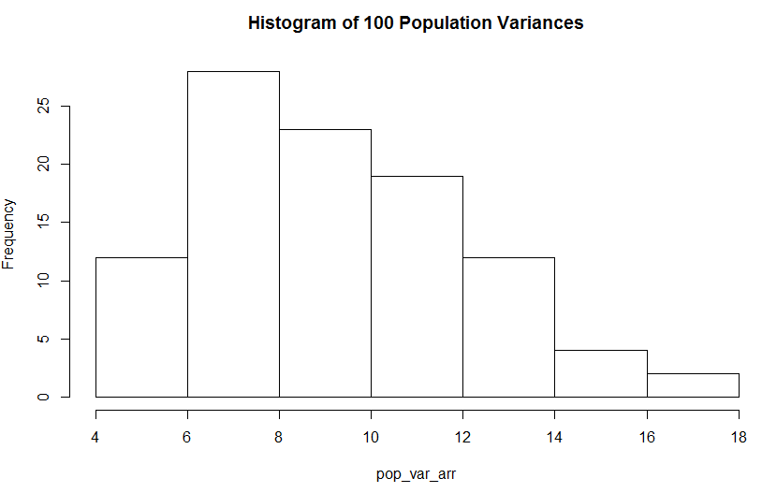

ii. 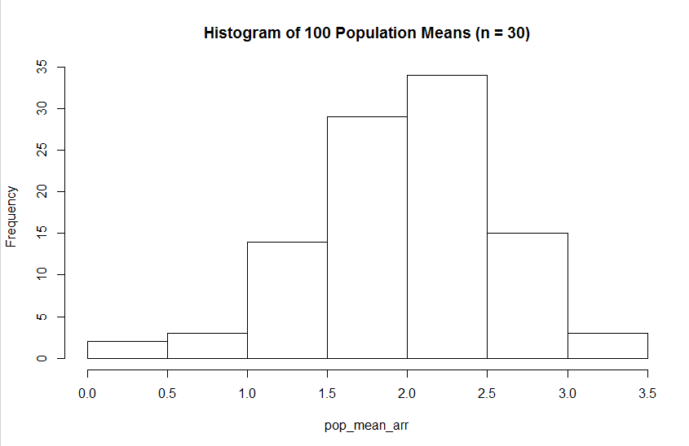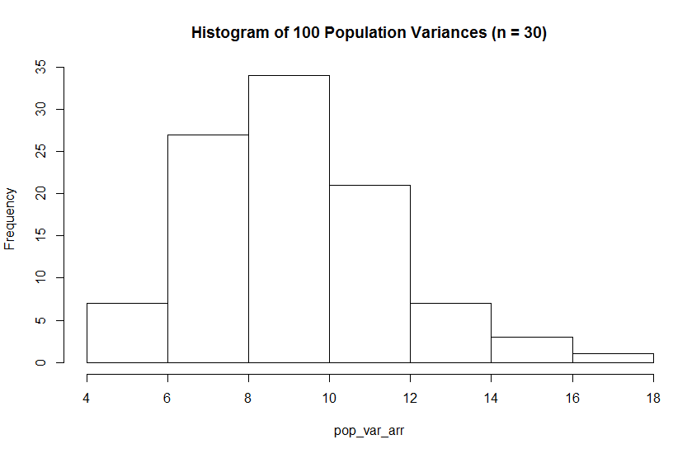

iii. 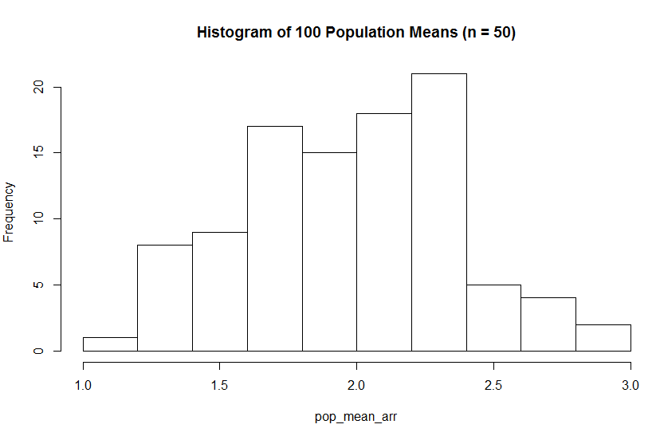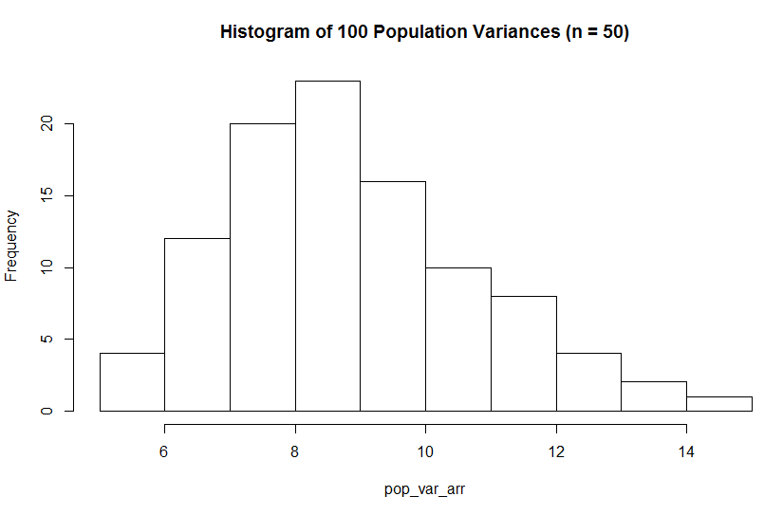

iv. As population size increases, the frequencies of mean and standard deviation approach the given values – the most common mean centers around 2, and the most common variation is 3^2, or 9. Testing this for n = 100 only continues to prove this.